Headstand Progressions
These progressions can help you work towards a perfect headstand!
- Make sure your back is fully stretched. We do this ‘cat stretch’ when we warm up before a session.
Coaching Points:
- Keep your arms as straight as possible, by your ears.
- Lean back onto your heels so that you can feel the stretch.
- Try and get your chest to the floor.
- Next, move on to this position. Have a go at transferring your weight to your head, using your hands to reduce the pressure.
Coaching Points:
- Try and keep your legs together and back arched.
- The top of your head should be on the floor.

- Try and move onto the balls of your feet.
Coaching Points:
- Try and keep your back straight.
- If this is hard, move your feet further away from your hands, but still keep your legs straight.
- If this is too easy, you can move your feet closer into your head, as shown:
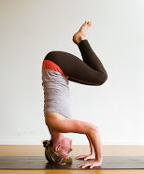
- Try and balance on just one foot, with the other in the air.
Coaching points:
- The majority of your weight should be on your head and hands, with your foot there to help you balance.
- If you have completed this, have a go at a tucked headstand!
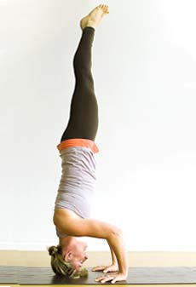

The full skill is a straight-legged headstand. It may be easier to make a triangle with your head and hands – your hands are the base of the triangle and your head is the point of the triangle. Push up slowly and squeeze your tummy muscles to keep your balance. Have fun practicing this skill!
Tripod Base:
Hand
Hand
Top of your head at the top point

